Task 1 – Creating Azure budget alerts.
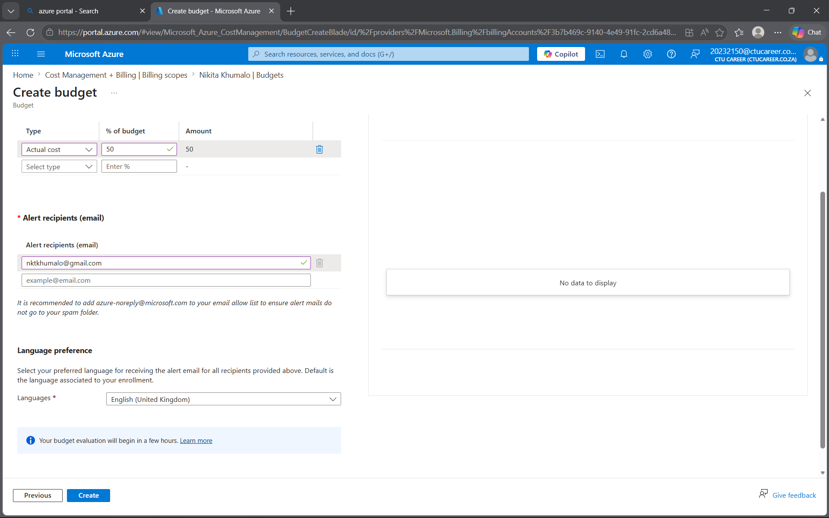

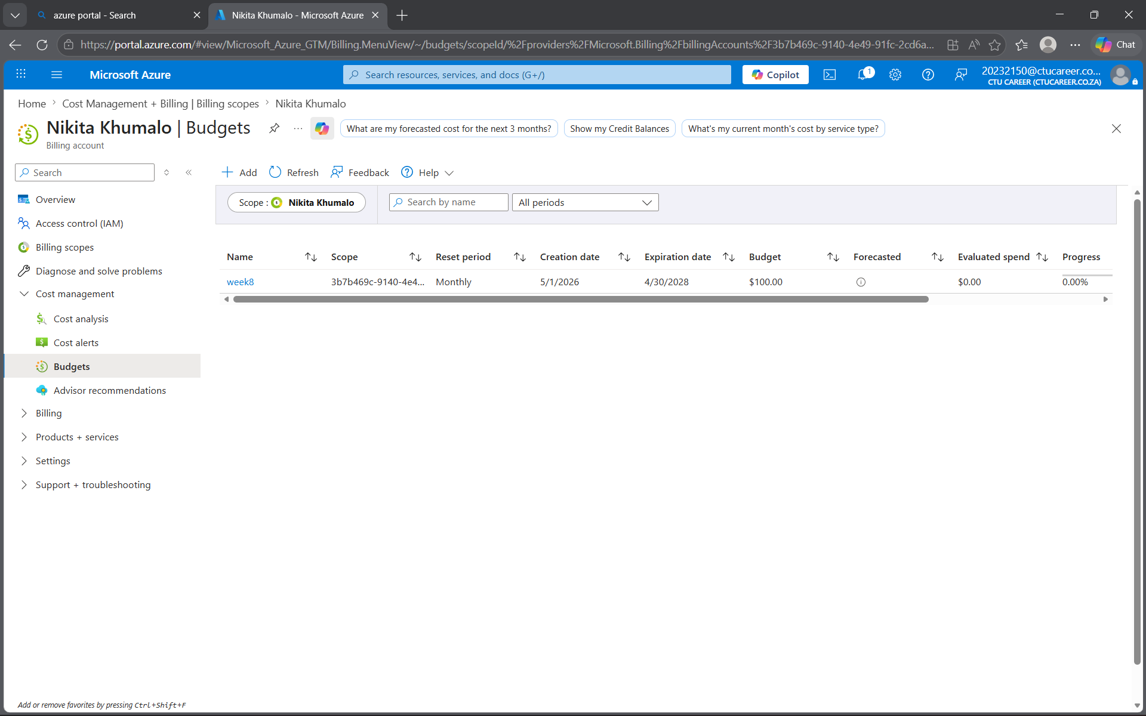
Task 2
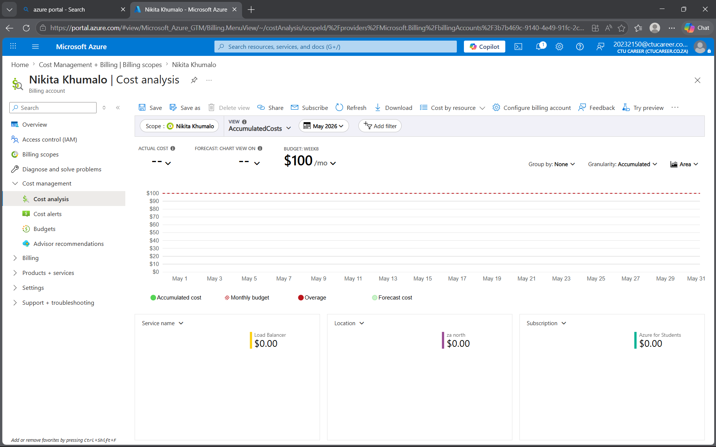
My average cost for a most is estimated to be $3. My recommendations to keep the costs low would be deleting any resources like the Virtual machine when its not in use because it is very costly if its running yet not used. Deleting mine is what kept my costs so low on average.
17. I was surprised by how quickly costs accumulated from running a VM continuously, even when it wasn’t actively used. The storage account costs were lower than expected compared to compute.
18. In production, cost management would require stricter governance: budgets per department, tagging resources for accountability, and automated alerts to prevent runaway costs. Decisions would balance performance, availability, and compliance — not just minimizing spend.
19. I would explore Cost Anomaly Detection to catch unusual spikes, Forecasting predicting future spend, and Advisor Recommendations that suggest cost optimizations like reserved instances or autoscaling.

